In this lesson we can install and set up Unity and latest version of Unity that is unity 6 So lets get started
So for it go to google and simply search download unity
and then click on the first link you see
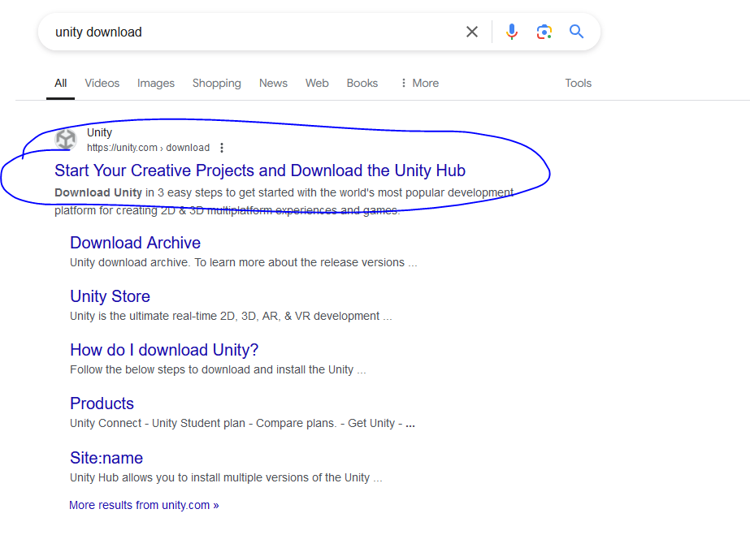
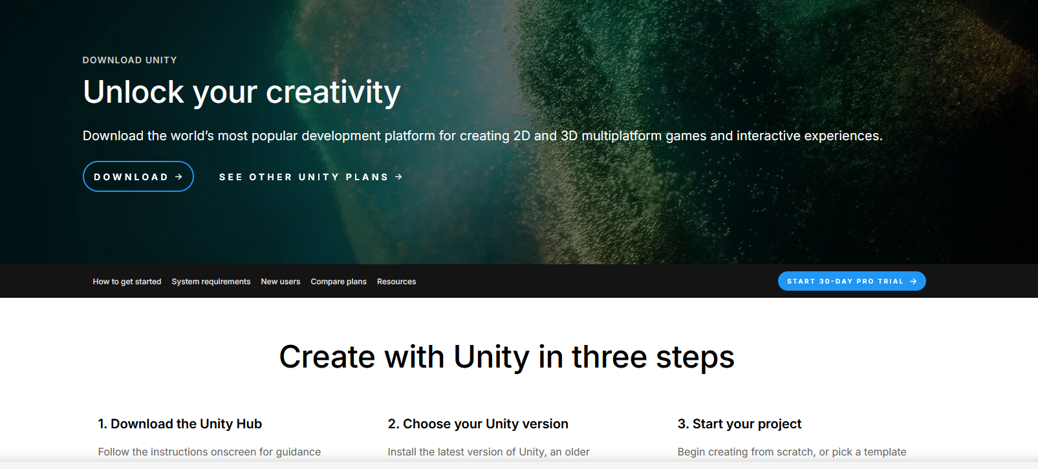
Now your download page will be shown here like this
Or you can go to the Unity.com website and make sure you create a new account.
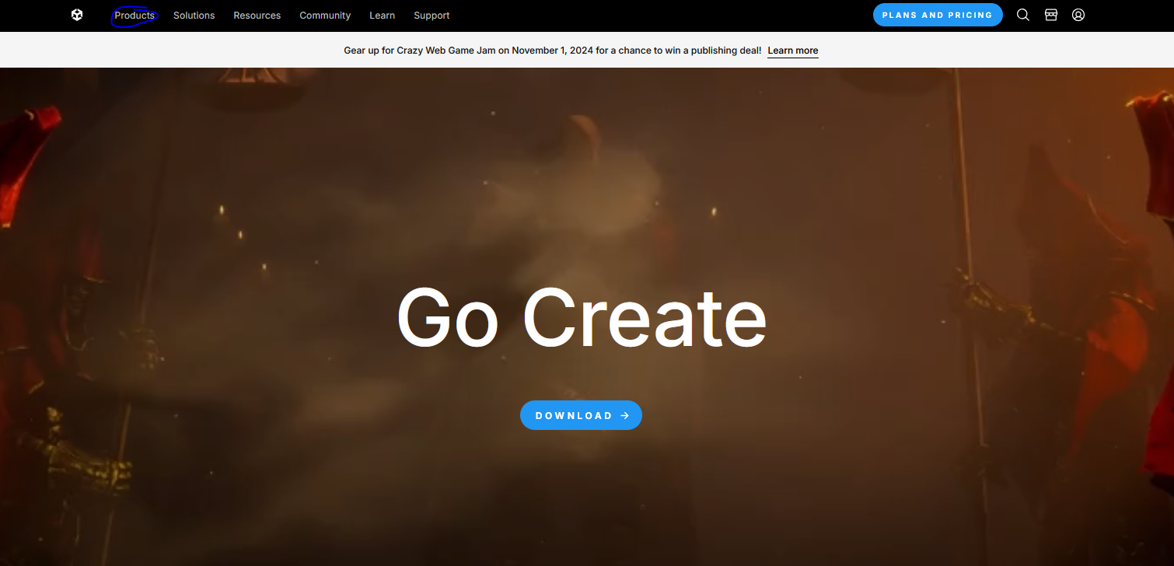
Then go to Product menu as marked above
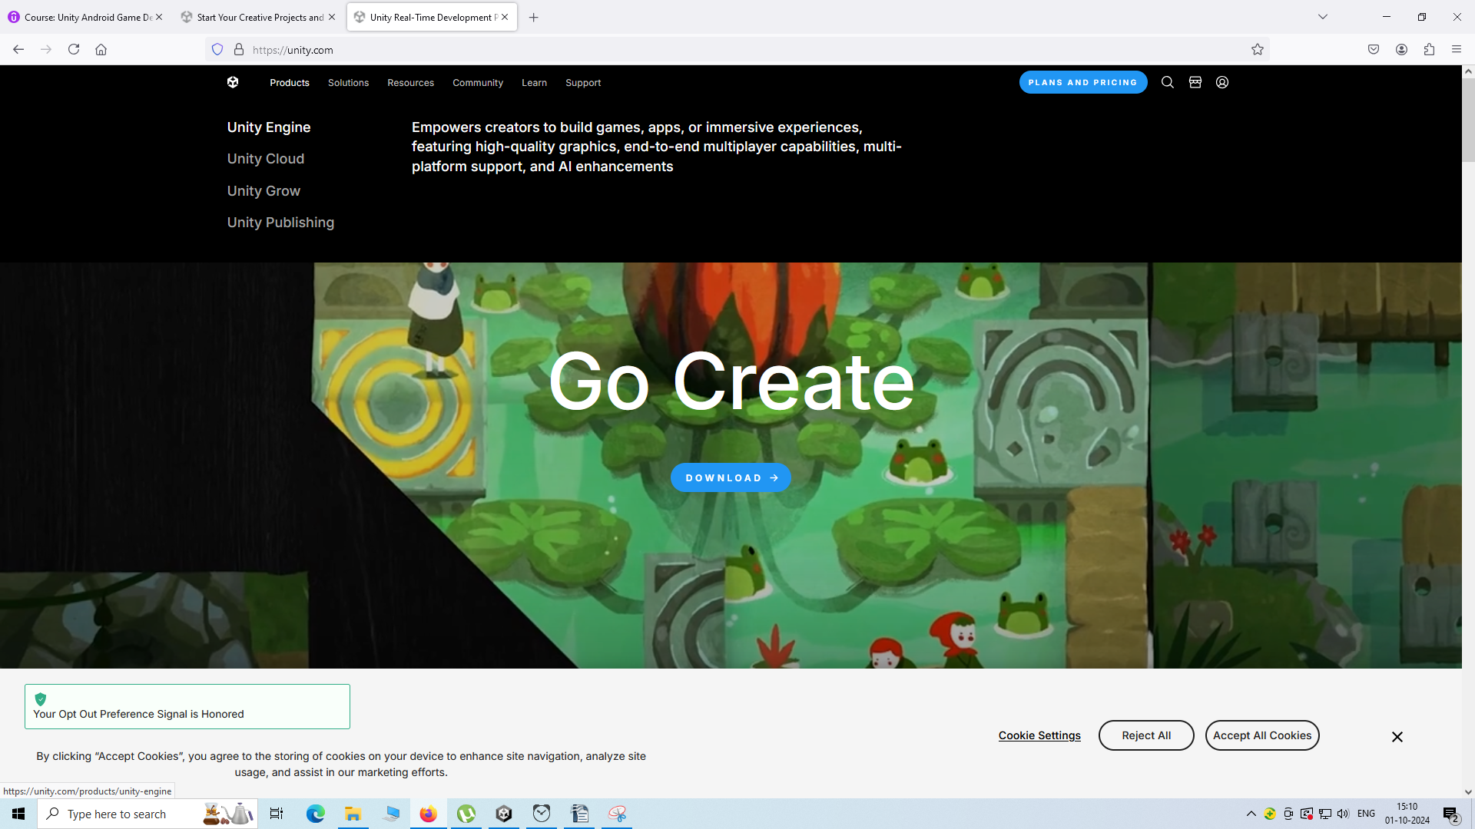
Now a submenu will be open then choose Unity Engine
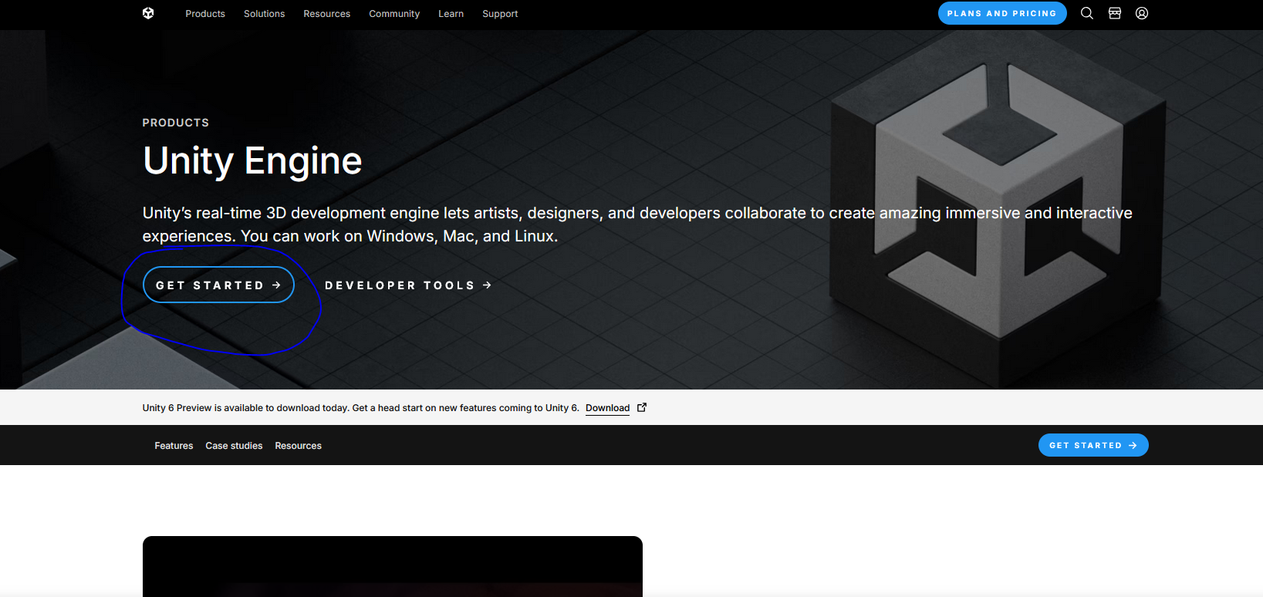
and then in new page that is loaded go to Get Started and then a new page is loaded as shown below
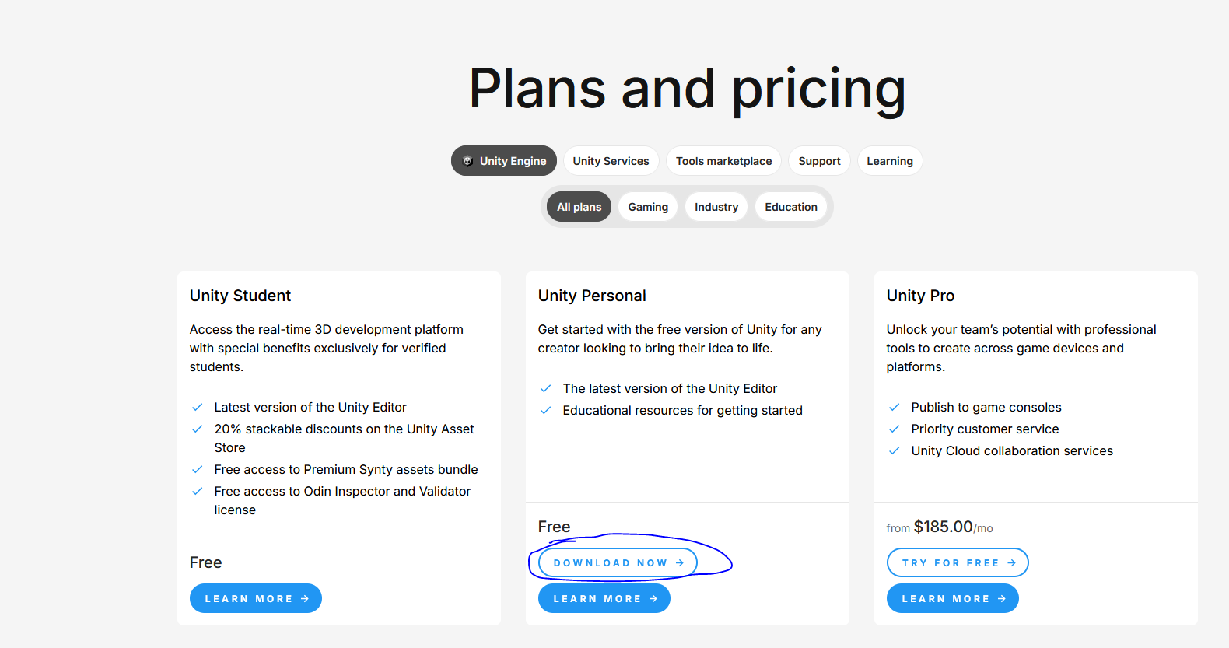
Now go to Unity Personal from above and then click on Download Now button.
You will be directed to the page below
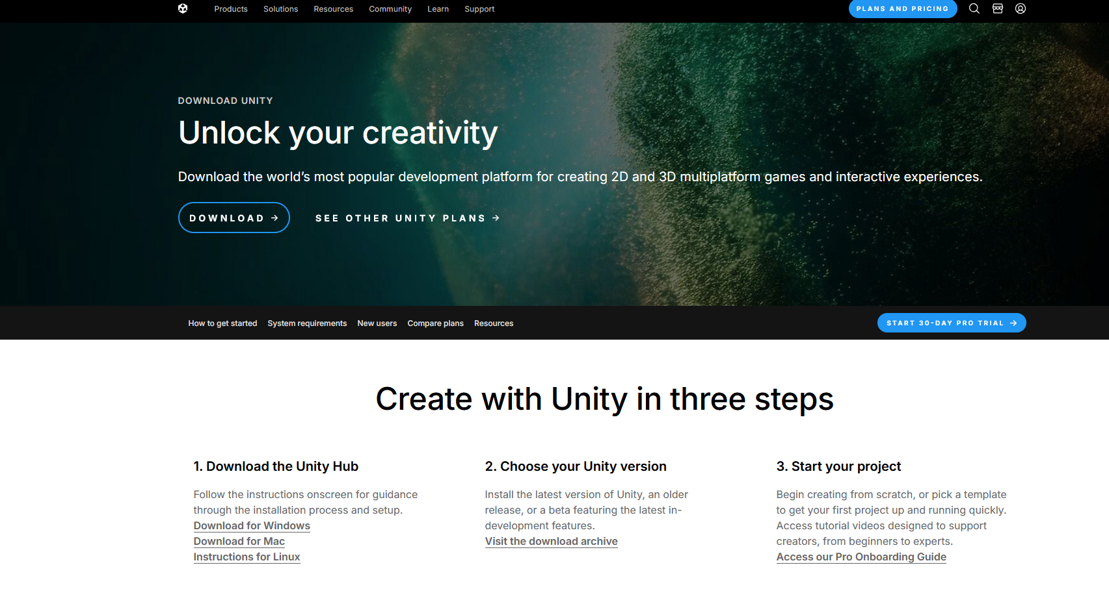
Now click on Download button then something will be downloaded called Unity Hub.
Unity helps you to download and install all the different version of unity and all the components of the unity game engine very easily
I have already downloaded and install unity hub
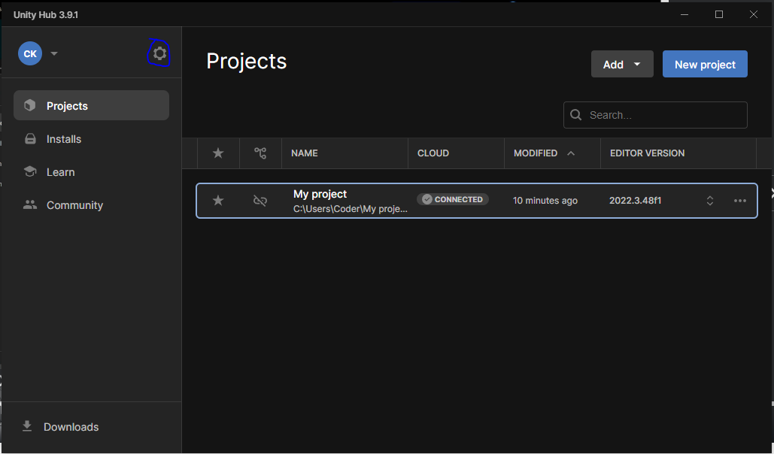
So i will open it and this will look like above.
You will see these four side tab that is
- Projects
- Installs
- Learn
- Community
The Projects Tab and Installs tabs are most important ones
Now go to gear button as marked above It is called Preference button.
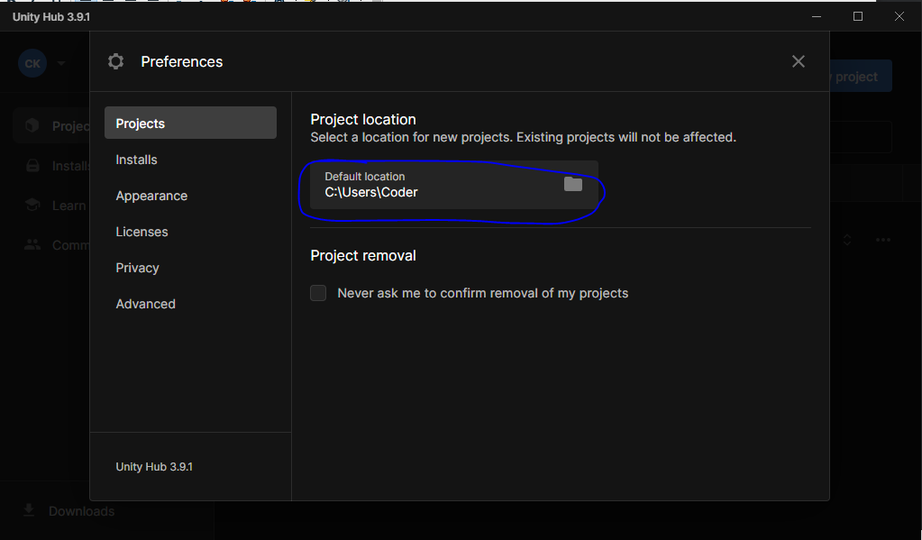
Now suddenly a mini window will open inside our Unity Hub window.
Now there is also some mini side tab that is
- Projects
- Installs
- Appearance
- License
- Privacy
- Advanced
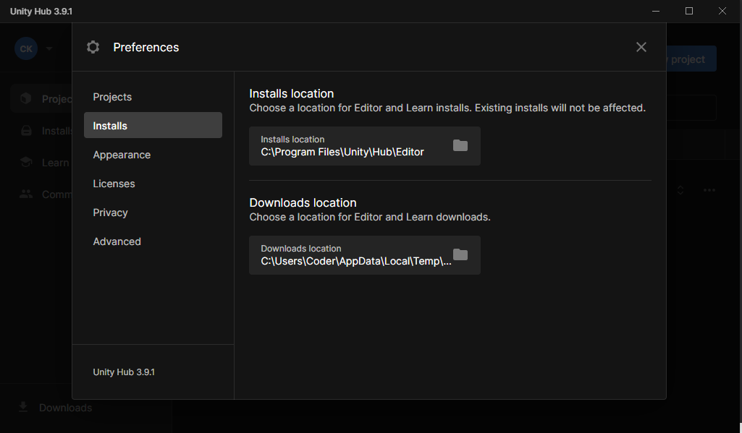
In Projects tab you can set Default location here where you can save your Unity Projects
In Installs tab you set the location of all your Unity Installs
If there is some specific folder where you want to keep all your installs then you can go ahead and then click on area as marked above
And then in Appearance tab you can choose light and Dark version
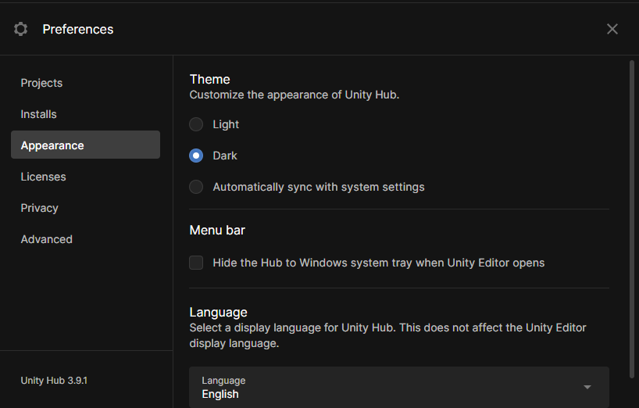
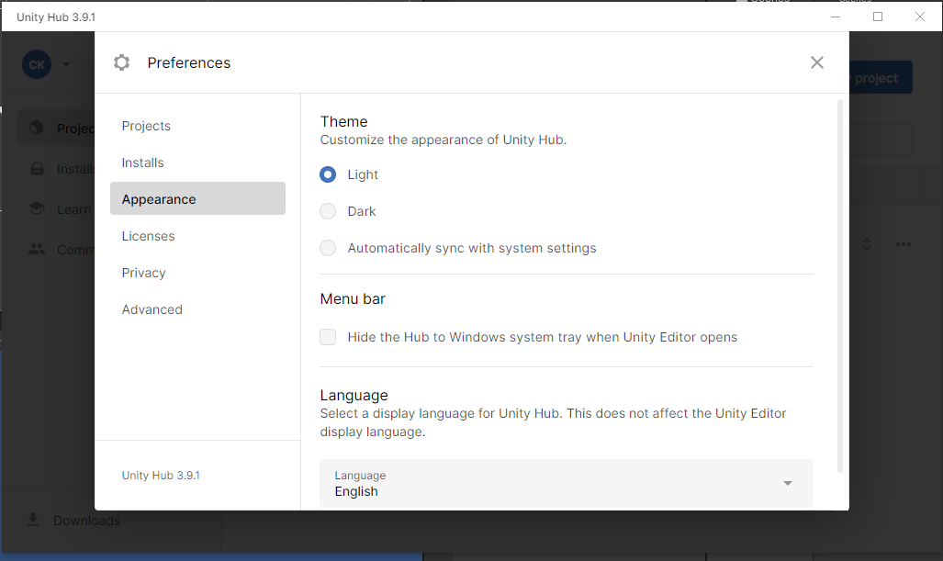
Now In Licenses tab you can see all your licenses
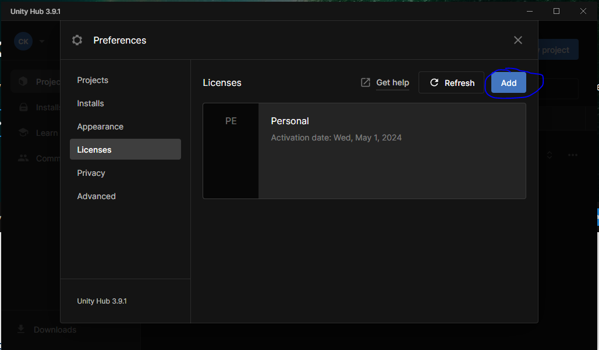
We have personal licenses that is free in Unity. You will need it to use unity if you don't have it then click on Add button give some details and then you will get your personal license Now once you have done that now its time to install it.
So after closing Preferences window Go to Installs side tab in Unity Hub Window.
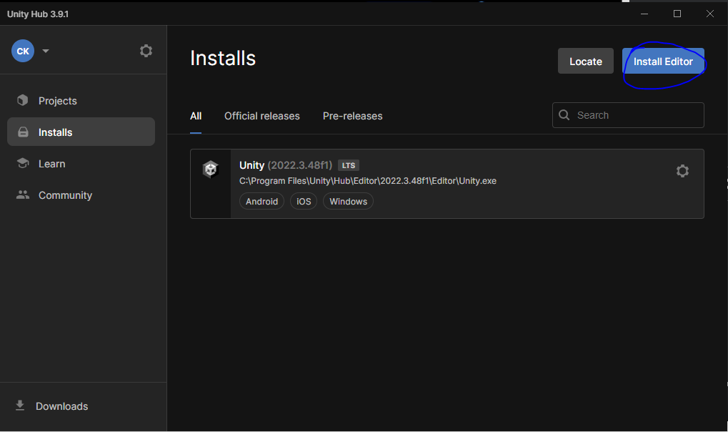
Here you will see three different tabs that is
- Projects
- Official releases
- Pre-releases
Now go to Install Editor button
A new window will opened like this
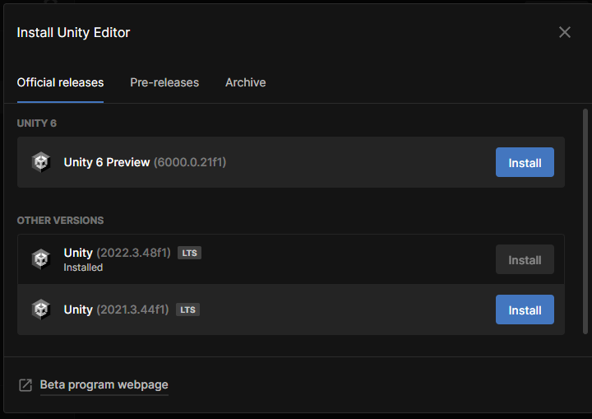
There will be three different tabs you see here .In official releases tab we can download the official releases
In pre releases we can download the beta version of the upcoming release that is to be released In archive we can go and download any old version of any project
Patch releses?(I don't know)
Now we are going to download the official release in most of the cases
If you are working on a project which you are going to maintain for long time. Lets say for 2 or three years. In that case it is recommended to download this long term support because then unity give support to these version for longer term because unity comes with new version every now and then. So if you want to use the same version over the yeears then you should always use this lts version.
Once you have choosen waht to install then click onits respective Install button.
Now you will see your unity hub window look like this
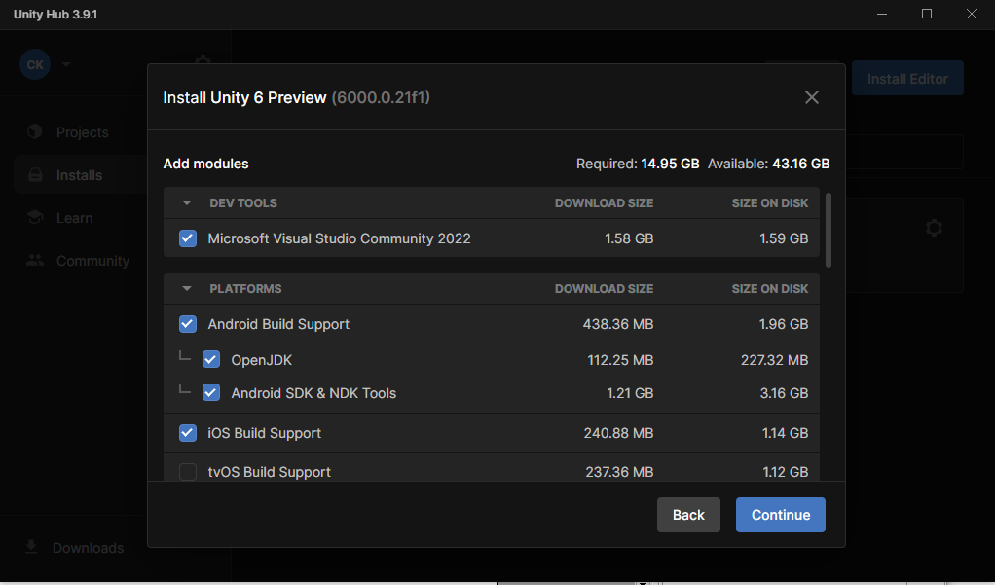
and now from here you can select the components you want to install
In dev tools
Microsoft Visual Studio Community 2022 editor is here
and in Platforms you can see several option here.
You need to download Microsoft Visual Studio Community for coding
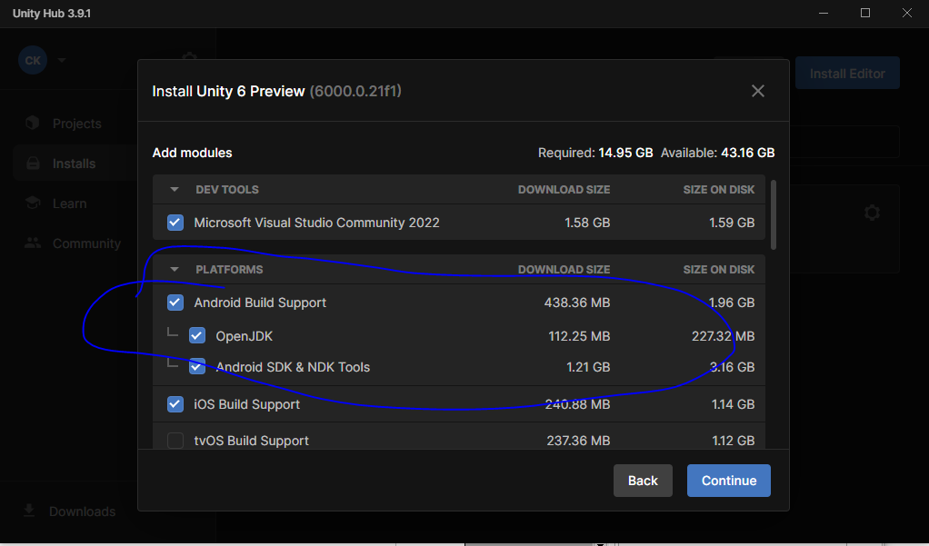
If you want to download and install Unity for Android. Then make sure to chose the checkbox Android Build Support as marked above.
Otherwise you will not be able to make games for android
For IOS build choose IOS Build Support below the marked one
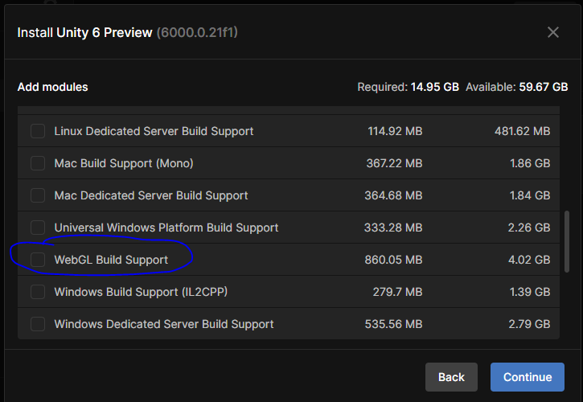
For web choose WebGL Build Support as marked above
No need to install documentation you can see the documentation of unity from Unity Doc websites
Now simply click on continue
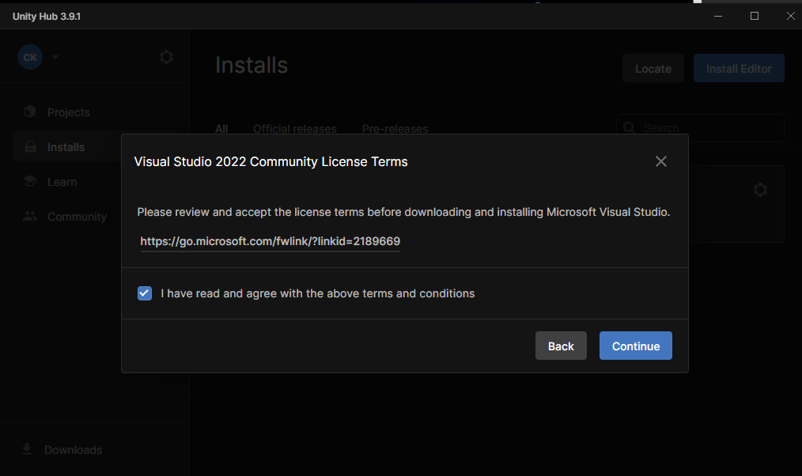
Check the checkbox of terms and condition and then click on Continue
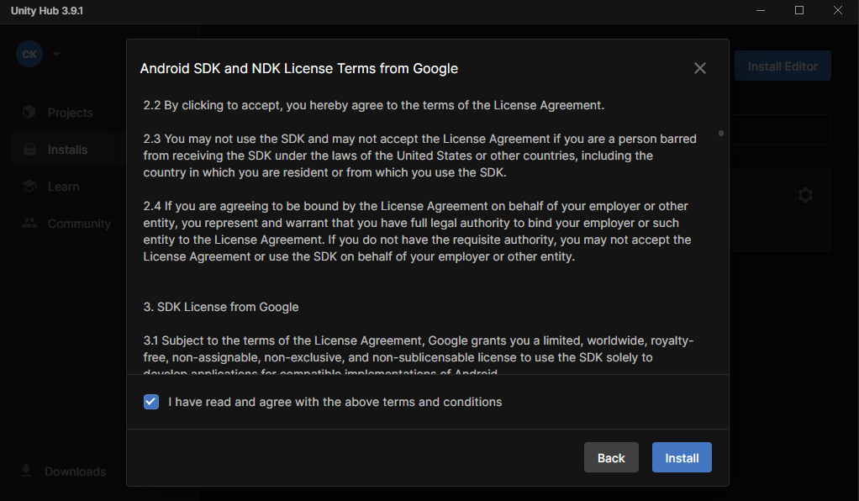
Click on i agree and then click on Install.
After this your install will be started one by one whatever you had chosen
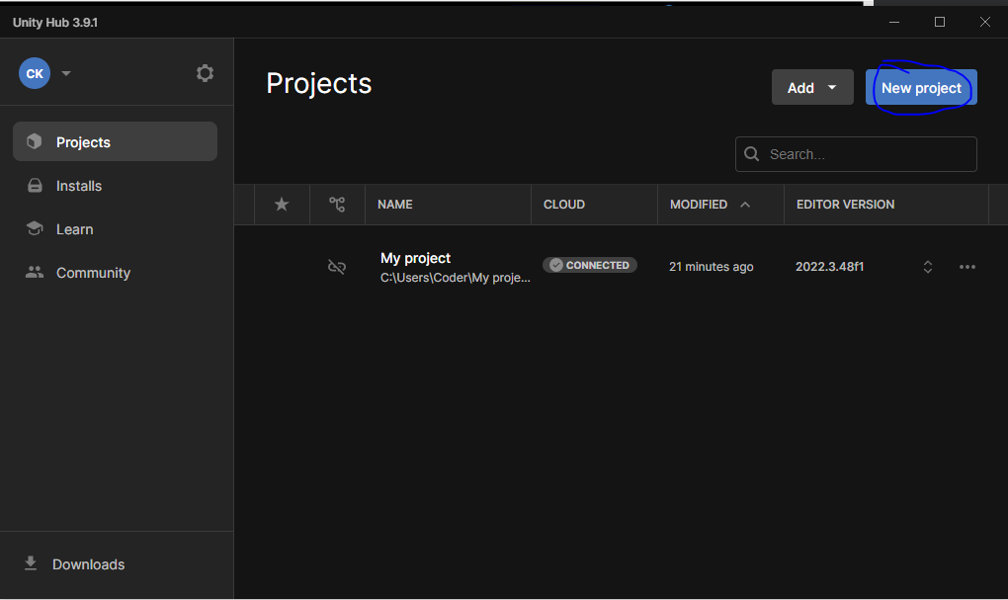
Now go to Project sidetab and then click on New Project as marked above
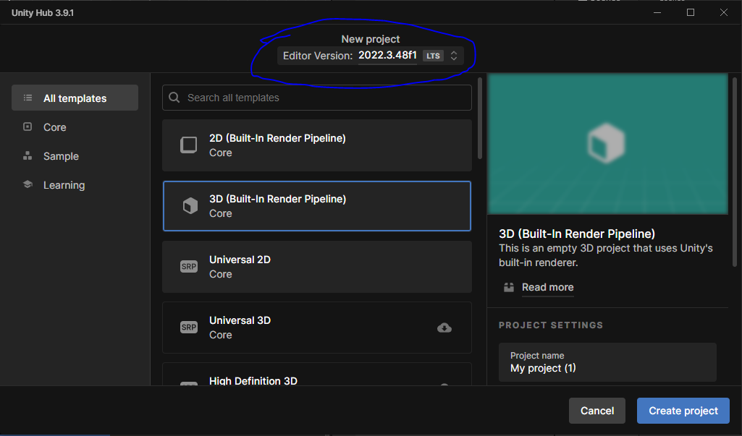
Now from above marked you can choose Editor version as marked above.
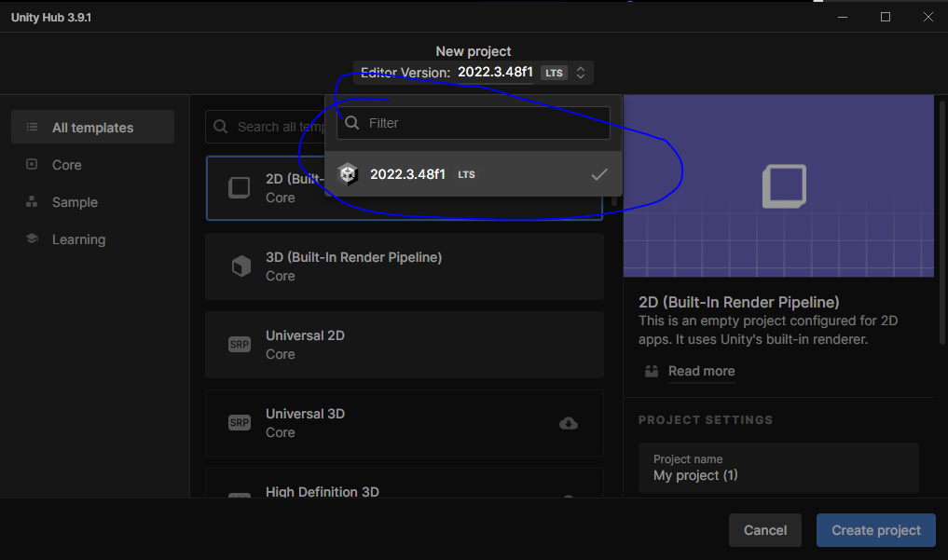
It will show the version like above
In your older version the teacher says that you have an option 2D (Built in Render Pipeline) and 3D (Built in Render Pipeline) as default render pipeline.
And in newer version you have Universal 2D and Universal 3D as default render pipeline.
If you don't have any of the render pipeline(I think here we are asking what type of project we are making 2D or 3D (maybe Renderer))
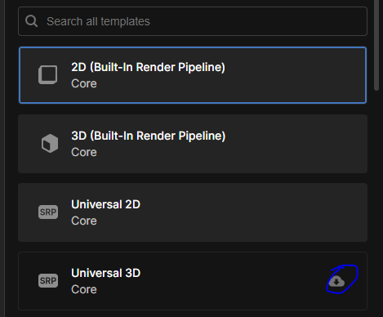
If you don't have any Renderer then go to beside that button as marked to download that renderer
Now we will create a new 2D project to show you the whole process Now lets choose 2D(Built in Render Pipeline)
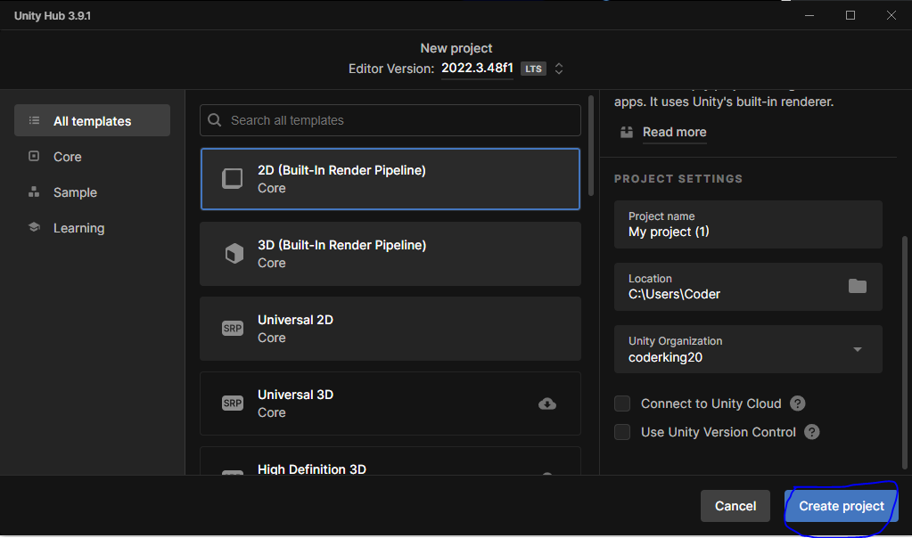
In right side of the window in project settings In Project Name tell the name of the project you want to make
In location tell the location where you want to save the project.
And now uncheck the Connect to Unity Cloud checkbox and then click on create Project button as marked above
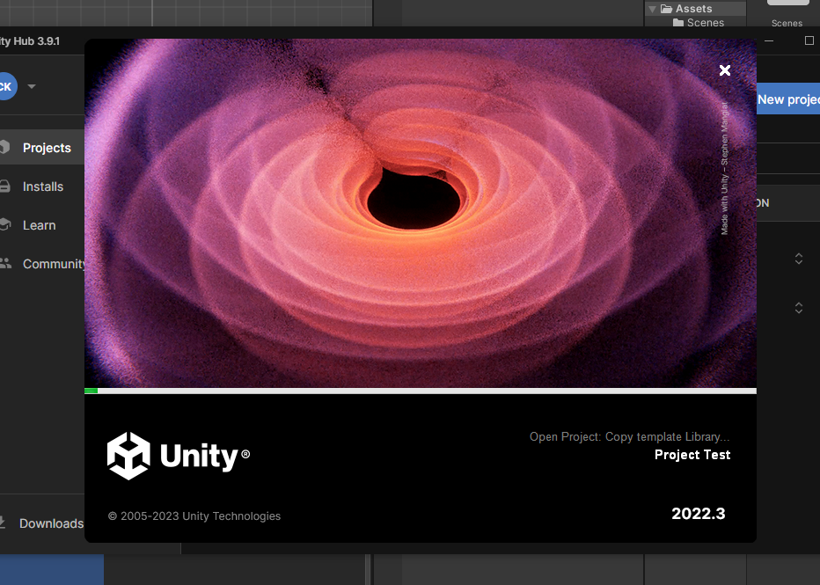
Now you can see the process that it is being created
And once it is done then it will open up the project on the Unity Editor.
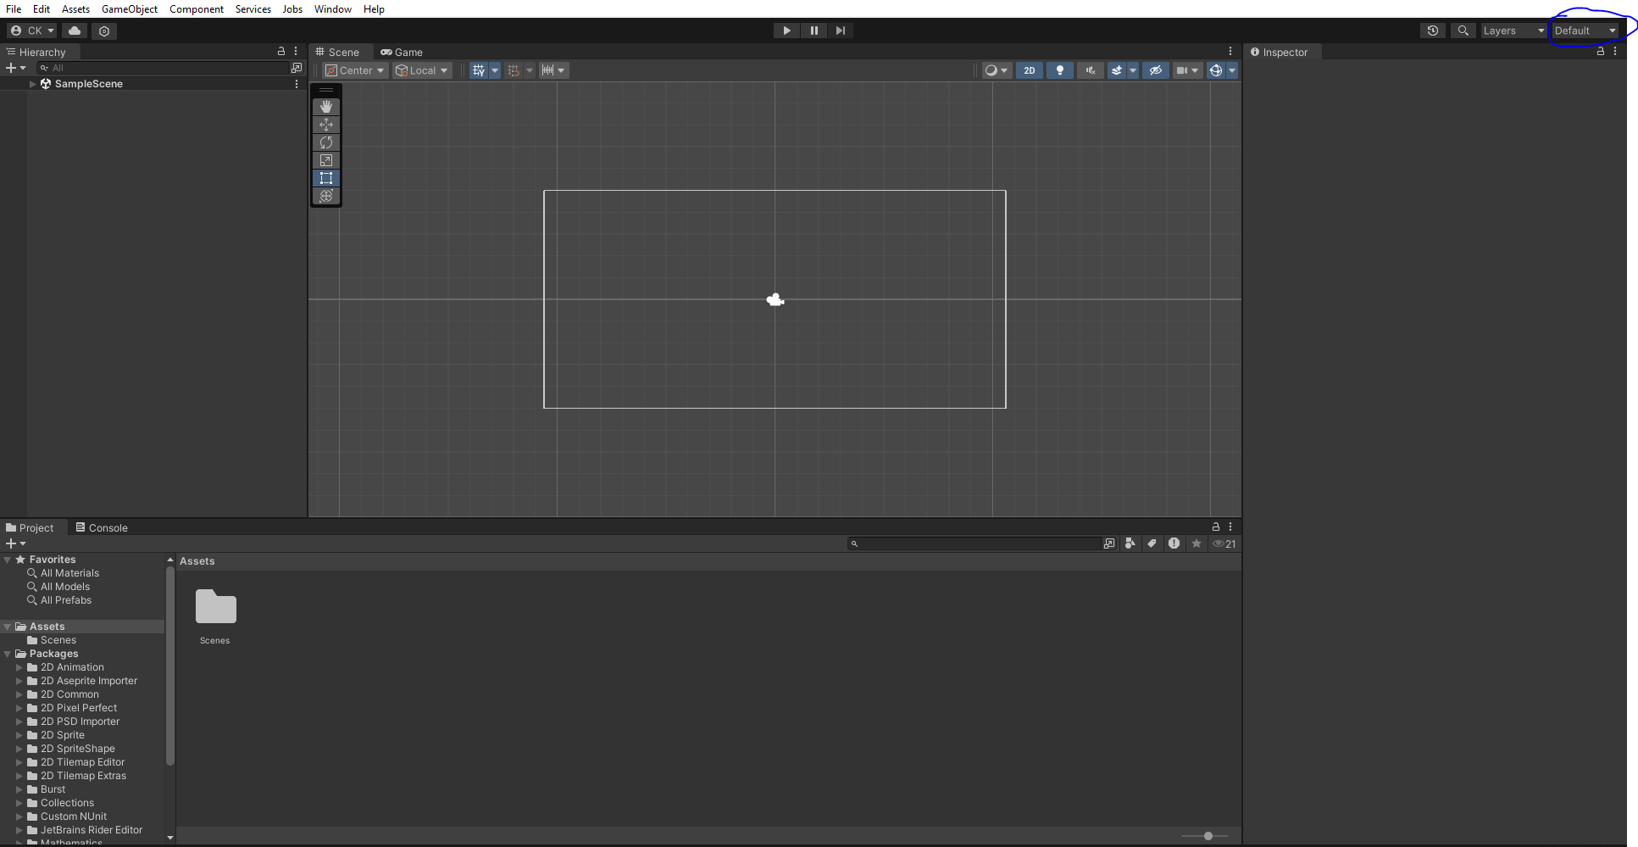
So we have 2D Unity Project opened. Now it is the default layout we see here.
So if you want to change this layout go to top right corner from the default a submenu will open
choose
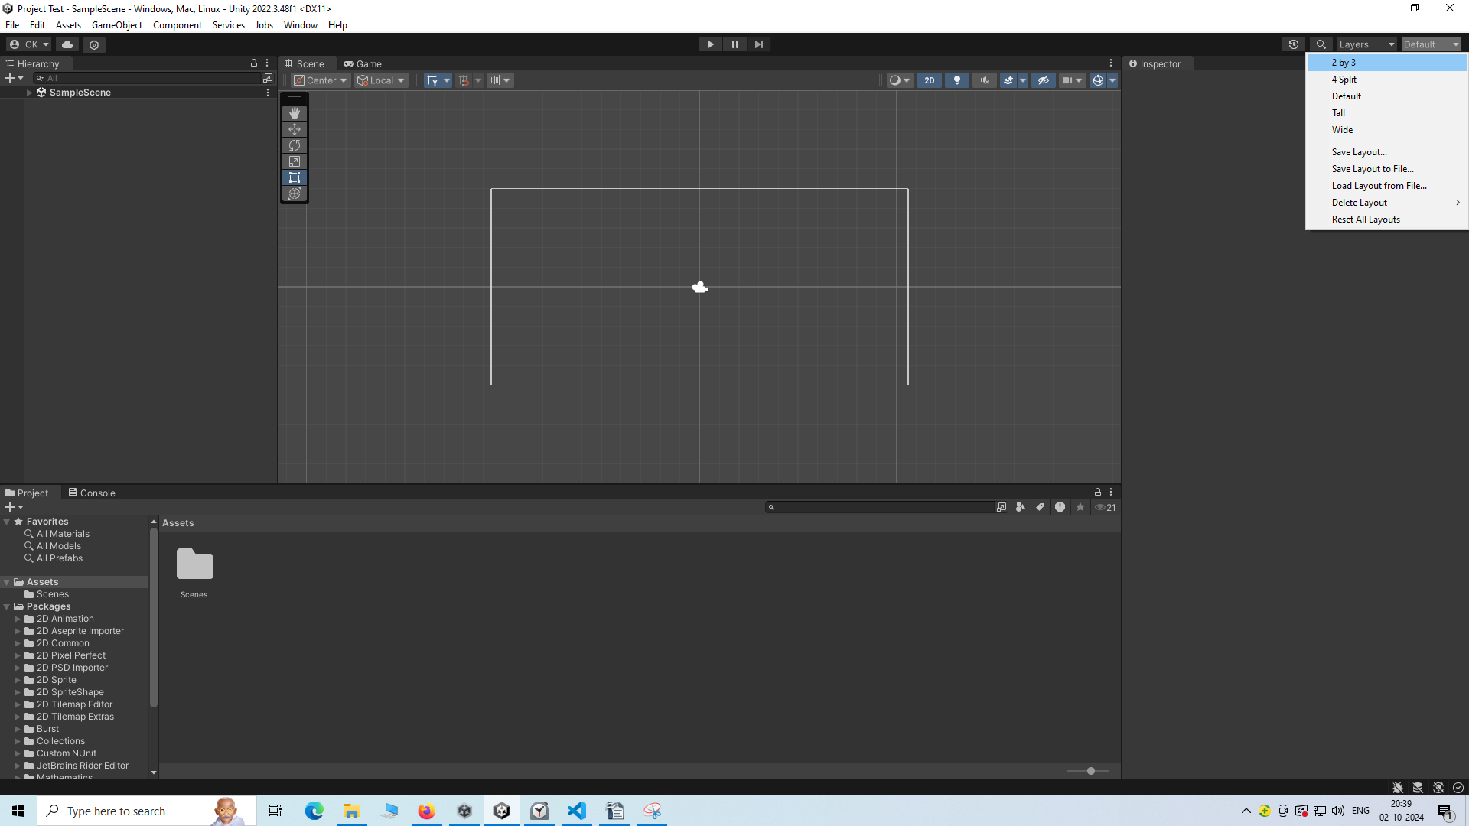
go to 2 by 3 now it will look like below


